

FACULTY OF COMPUTING
SEMESTER 2 2024/2025

SECJ2154 OBJECT ORIENTED PROGRAMMING
SECTION 03
MINI PROJECT
ONLINE SHOPPING CART

LECTURER: DR MUHAMMAD KHATIBSYARBINI ABD RAHIM
Student Name | Matric No.
LAM YOKE YU | A23CS0233
GOE JIE YING | A23CS0224

Video Presentation Link:
https://drive.google.com/file/d/17-Dbb2TPiXqPb0uQNWTDTSZNkf_Hsoqc/view?usp=sharing
GitHub Repository Link:
https://github.com/jygoe/The-GHL-Shooopppping-Gliccchedd-Carrrt

1.0 Project Description
This project is a console-based online shopping cart system built in Java. It supports:
- Customers browse and add items to the shopping cart
- Administrators manage items and view/update customer orders (shopping cart)
The system uses object-oriented design principles to simulate real e-commerce scenarios, and applies Java's collection framework and exception handling to enhance functionality and stability.

2.0 Functional Requirement
The Online Shopping Cart System provides role-based functionality for both administrators and customers.

2.1 Admin Functionalities
- View All Carts
- Admins can view all shopping carts created by customers.
- Each cart displays customer ID, item IDs, names, variant details, prices, and status.

- Update Cart Status
- Admins can select a cart by its ID and update its status.
- Each cart’s status can be changed to either Processing, Shipped, or Completed.

- View Items
- Admins can view the item catalog in a table.
- Each item shows its ID, name, description, variants, price, and quantity.

- Update Items
- Admins can select an item by ID and:
  - Change the item’s name, OR
  - Change the item’s description, OR
  - Update a specific variant (name, price, quantity), OR
  - Add new variants to the item

- Add New Item
- Admins can add new items to the catalog by entering:
  - Item name and description
  - One or more variants (name, price, quantity)

2.2 Customer Functionalities
- Add Cart (Place Order)
- Customers can view available items and their variants.
- Customers select items by their item ID and choose a variant.
- The system checks if the selected variant is in stock.
- Once confirmed, the item is added to the customer’s cart.
- Multiple items can be added before confirming the cart.

3.0 Topic Implemented

3.1 Chapter 5 Vectors & Collections
The ArrayList class is used to manage dynamic collections of objects. It stores different objects, such as users, items, and cart records without predefining the number of entries. The use of ArrayList allows the system to easily add, remove, and loop through elements.

Examples:
- ArrayList<User> users: stores both Customer and Admin accounts
- ArrayList<Item> items: stores the list of items
- ArrayList<Integer> variantIndex: stores different variant of a product

3.2 Chapter 6 Class Relationships

3.2.1 Association
The Cart class has an association with the Customer class with each cart belonging to a specific customer and customer is stored as a reference within the Cart object.

Example:
In Cart class, “private Customer customer;” exists.

3.2.2 Aggregation
The CartHistory class stores all Cart objects in an ArrayList. These carts can exist independently from the history, which shows a "has-a" but not "owns" relationship.

Example:
In CartHistory class, “private ArrayList<Cart> carts” exists.

3.2.3 Composition
The Cart class holds selected items and variant indices. When a Cart is destroyed, its combination of items and selections no longer holds meaning.

Example:
In Cart class, “private ArrayList<Item> items; private ArrayList<Integer> variantIndex;”

3.3 Chapter 7 Inheritance
Inheritance is used in this system to promote code reuse and reduce redundancy. A base class User is defined with shared attributes and methods such as userId, password, and role. The Customer and Admin classes extend the User class to inherit these common features.

Example:
class User {
protected String userId;
protected String password;
protected int role;
...
}
class Customer extends User { ... }
class Admin extends User { ... }

3.4 Chapter 8 Polymorphism
Polymorphism allows a single variable of a superclass type to refer to objects of different subclasses. In this system, both Customer and Admin objects are stored in an ArrayList<User>.

Example:
ArrayList<User> users = new ArrayList<>();
users.add(new Customer("C1", "123"));
users.add(new Admin("A1", "123"));

3.5 Chapter 9 Exception Handling
Exception handling is used in the program to manage errors that occur during user input. This prevents the program from crashing and improves user experience. try-catch blocks are used to catch exceptions such as InputMismatchException and NumberFormatException.

Example:
try {
choice = scanner.nextInt();
scanner.nextLine();
} catch (InputMismatchException e) {
System.out.println("Invalid input. Please enter a number.");
scanner.nextLine(); }

4.0 Sample Output

4.1 Admin View

4.1.1 Admin Login
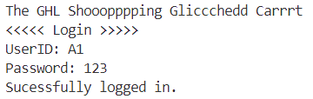

4.1.2 Admin Main Menu
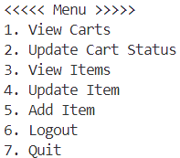

4.1.3 Admin View Carts (Choice 1)
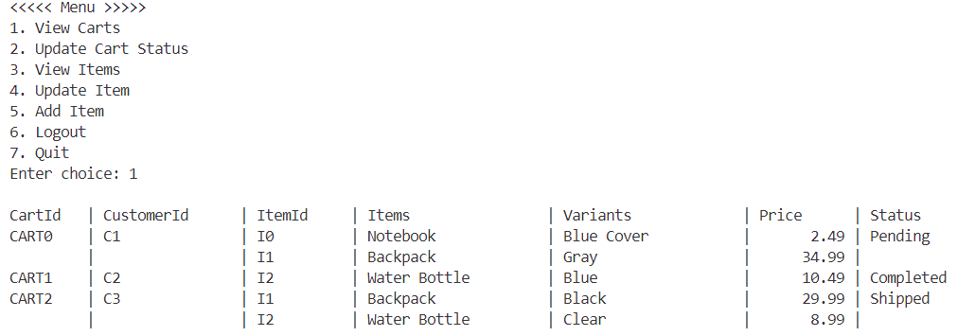

4.1.4 Admin Update Cart Status (Choice 2)
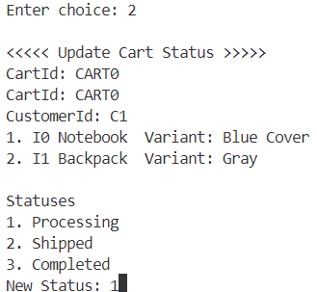

4.1.5 Admin View Items (Choice 3)
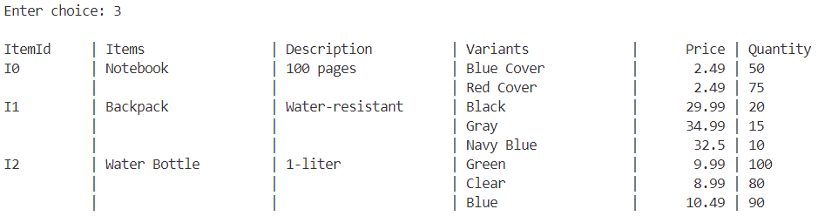

4.1.6 Admin Update Items (Choice 4)
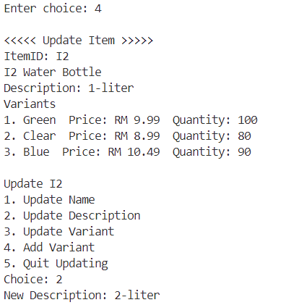

4.1.7 Admin Add Item (Choice 5)
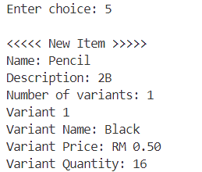

4.2 Customer View

4.2.1 Customer Login
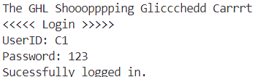

4.2.2 Customer Main Menu
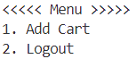

4.2.3 Customer Add Cart (Choice 1)
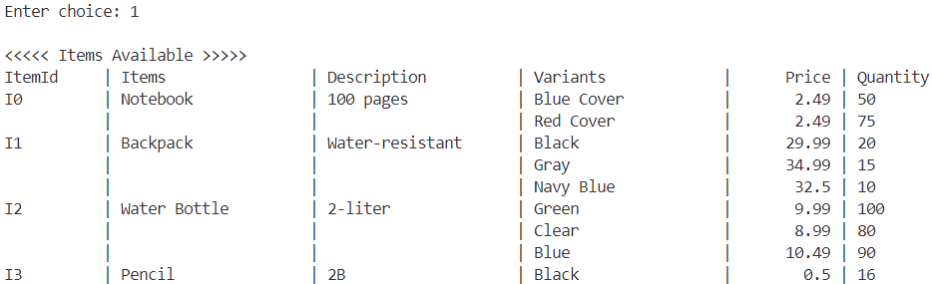
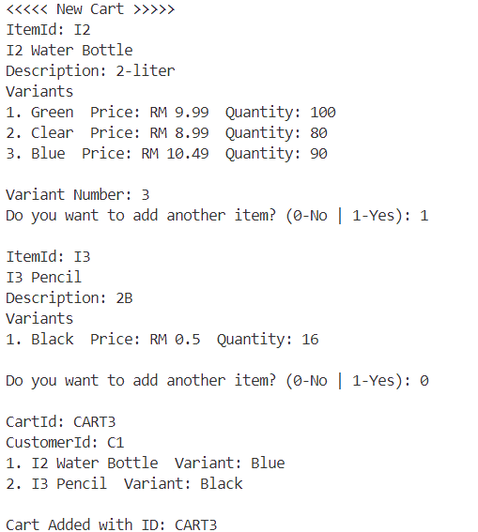

5.0 Class Diagram
